 | F/UTP cat.6 4x2x0,54 LSZH

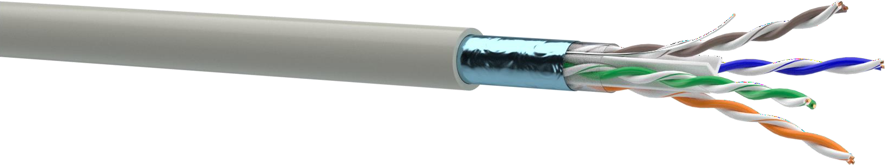
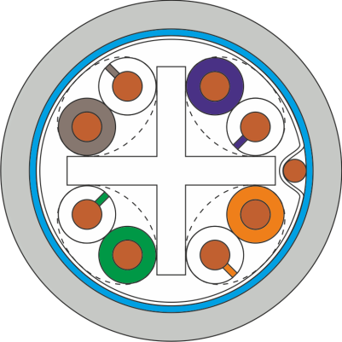

DESIGN
- Conductor: soft copper wire, nominal Ø 0,54 mm
- Insulation: PE, Ø 1,09 mm
- Pair: two conductors twisted together
- Cross-web: PE, 4x4 mm
- Core wrapping
- Copper tinned contact wire Ø 0,4 mm
- Core shield: aluminum polymer foil (metal outside)
- Sheath: LSZH, nominal cable diameter: 6,8 mm
APPLICATION  PBX, V.11, X.21, ISDN, Ethernet (10Base-T), ATM-25/52/155  Mbit/s, 100VG-AnyLAN, Fast Ethernet (100BASE-TX), Token Ring 16/100 Mbit/s, Gigabit Ethernet (1000BASE-T), Firewire 100 Mbit/s, 10 Gigabit Ethernet (10GBASE-T*), ATM LAN 1,2 Gbit/s | INSTALLATION AND OPERATION CONDITIONS  For stationary installation inside buildings, stations, structures and equipment in conditions of heightened electromagnetic impacts. Operated on frequencies up to 250 MHz.
СOMPLIANCE WITH THE REQUIREMENTS System: ISO/IEC 11801, EN 50173-1, ANSI/TIA 568-С.2 Cable: IEC 61156-5  Fire safety: IEC 60332-1, IEC 61034-1, IEC 60754-2  CPR class: Eca | MECHANICAL CHARACTERISTICS  Тemperature range:  During installation -10 °C ... +60 °C After installation -20 °C ... +60 °C  Bending radius:  During installation ≥ 8 cable diameters After installation ≥ 4 cable diameters  Tensile stress ≤ 85 N

ELECTRICAL CHARACTERISTICS AT 20 °C
Parameter | Unit | Value
Capacitance | pF/m | ≤ 56
Direct current resistance | Оhm/km | ≤ 85
Insulation resistance | GOhm/km | ≥ 5
Resistance unbalance | % | 2
Signal propagation velocity | s | 0,68
Propagation delay | ns/100 m | ≤ 534+36/√f
Delay shift on the frequency 100 MHz | ns/100 m | ≤ 30
Characteristic impedance in the frequency range of: 1-100 MHz  100-250 MHz | Ohm | 100±15  100±22
Test voltage between cores, (DC, 2 s) | kV | 2,5

Frequency, MHz | 1 | 4 | 10 | 16 | 20 | 31,25 | 62,5 | 100 | 125 | 200 | 250
Attenuation, dB, max | 2,1 | 3,8 | 6 | 7,6 | 8,5 | 10,8 | 15,5 | 19,9 | 22,5 | 29,1 | 33
NEXT, dB, min | 75,3 | 66,3 | 60,3 | 57,3 | 55,8 | 52,8 | 48,3 | 45,3 | 43,8 | 40,8 | 39,3
PS NEXT, dB, min | 72,3 | 63,3 | 57,3 | 54,3 | 52,8 | 49,8 | 45,3 | 42,3 | 40,8 | 37,8 | 36,3
ELFEXT, dB, min | 68 | 56 | 48 | 44 | 42 | 38 | 32 | 28 | 26 | 22 | 20
PS ELFEXT, dB, min | 65 | 53 | 45 | 41 | 39 | 35 | 29 | 25 | 23 | 19 | 17
RL, dB, min | 20,0 | 23,0 | 25,0 | 25,0 | 25,0 | 23,6 | 21,5 | 20,1 | 19,4 | 18,0 | 17,3
IEC 61156-5, values lower than 4 MHz are given for information only

